ASSIGNMENT
Advantages of JAVA

- Platform Independent
Java follows the "Write Once, Run Anywhere (WORA)" principle. Java programs can run on any system that has the Java Virtual Machine (JVM).
- Object-Oriented
Java is based on object-oriented programming (OOP), which promotes code reusability, modularity, and easier maintenance.
- Simple and Easy to Learn
Java has a straightforward syntax, making it easier to learn compared to many other programming languages.
- Secure
ava provides built-in security features such as bytecode verification, exception handling, and the absence of explicit pointers, reducing security risks.
- Robust
Strong memory management, automatic garbage collection, and exception handling make Java reliable and less prone to crashes.
- Multithreaded
Java supports multithreading, allowing multiple tasks to run simultaneously for better performance.
- High Performance
Although not as fast as some compiled languages, Java uses Just-In-Time (JIT) compilation to improve execution speed.
- Distributed
Java provides libraries and APIs for developing distributed applications and network-based programs.
- Portable
Java programs can be easily moved from one platform to another without modification.

- Rich Standard Library
Java offers extensive built-in libraries for networking, database connectivity, GUI development, file handling, and more, reducing development effort.

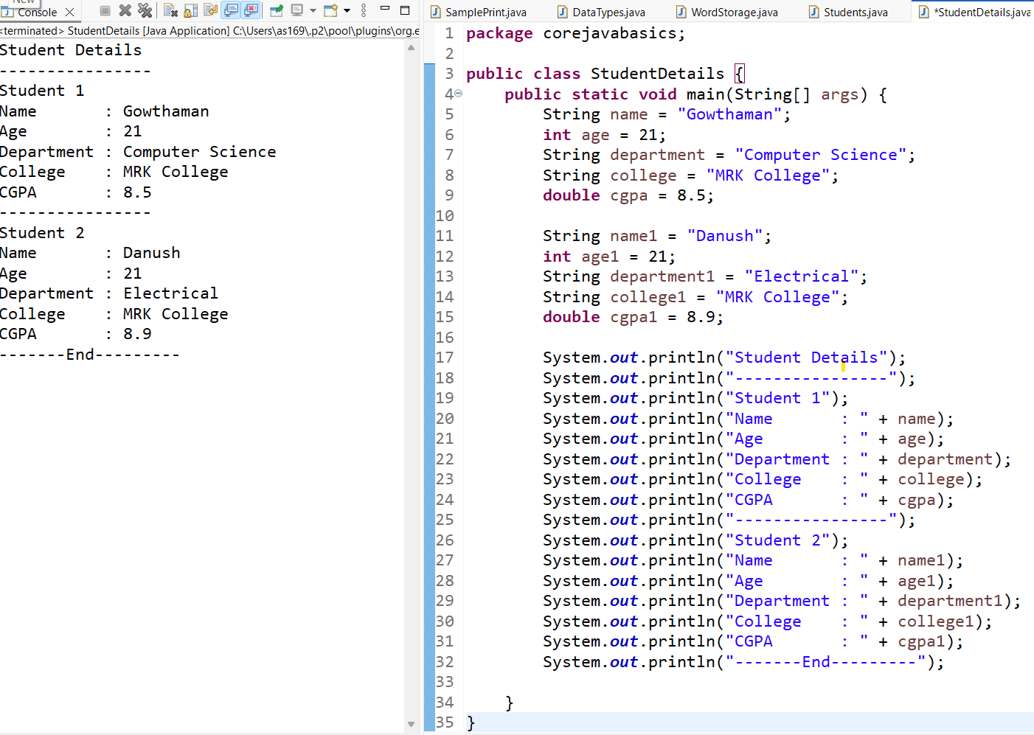
Students Details:

JAVA Code:
package corejavabasics;
public class StudentDetails {
public static void main(String[]args) {
String name = "Gowthaman";
int age = 21;
String department = "Computer Science";
String college = "MRK College";
double cgpa = 8.5;

String name1 = "Danush";
int age1 = 21;
String department1 = "Electrical";
String college1 = "MRK College";
double cgpa1 = 8.9;

System.out.println("Student Details");
System.out.println("----------------");
System.out.println("Student 1");
System.out.println("Name : " + name);
System.out.println("Age : " + age);
System.out.println("Department : " + department);
System.out.println("College : " + college);
System.out.println("CGPA : " + cgpa);
System.out.println("----------------");
System.out.println("Student 2");
System.out.println("Name : " + name1);
System.out.println("Age : " + age1);
System.out.println("Department : " + department1);
System.out.println("College : " + college1);
System.out.println("CGPA : " + cgpa1);
System.out.println("-------End---------");

}
}

